Week 7
Write a C program to simulate:
a) Bankers’ algorithm for the purpose of deadlock avoidance.
b) Deadlock Detection

a)
#include <stdio.h>

int main()
{
int p, r;

int alloc[10][10], max[10][10], need[10][10];
int avail[10];

int finish[10] = {0};
int safe[10];

int i, j, k;
int count = 0;

printf("Enter number of processes: ");
scanf("%d", &p);

printf("Enter number of resources: ");
scanf("%d", &r);

printf("\nEnter Allocation Matrix:\n");
for(i = 0; i < p; i++)
{
for(j = 0; j < r; j++)
{
scanf("%d", &alloc[i][j]);
}
}

printf("\nEnter Max Matrix:\n");
for(i = 0; i < p; i++)
{
for(j = 0; j < r; j++)
{
scanf("%d", &max[i][j]);
}
}

printf("\nEnter Available Resources:\n");
for(i = 0; i < r; i++)
{
scanf("%d", &avail[i]);
}

for(i = 0; i < p; i++)
{
for(j = 0; j < r; j++)
{
need[i][j] = max[i][j] - alloc[i][j];
}
}

printf("\nNeed Matrix:\n");
for(i = 0; i < p; i++)
{
for(j = 0; j < r; j++)
{
printf("%d ", need[i][j]);
}
printf("\n");
}

while(count < p)
{
int found = 0;

for(i = 0; i < p; i++)
{
if(finish[i] == 0)
{
int exec = 1;

for(j = 0; j < r; j++)
{
if(need[i][j] > avail[j])
{
exec = 0;
break;
}
}

if(exec == 1)
{
for(k = 0; k < r; k++)
{
avail[k] = avail[k] + alloc[i][k];
}

safe[count] = i;
count++;
finish[i] = 1;
found = 1;
}
}
}

if(found == 0)
{
break;
}
}

if(count == p)
{
printf("\nSystem is in Safe State\n");

printf("Safe Sequence:\n");

for(i = 0; i < p; i++)
{
printf("P%d", safe[i]);

if(i != p - 1)
{
printf(" -> ");
}
}
}
else
{
printf("\nSystem is NOT in Safe State\n");
}

return 0;
}

Output:

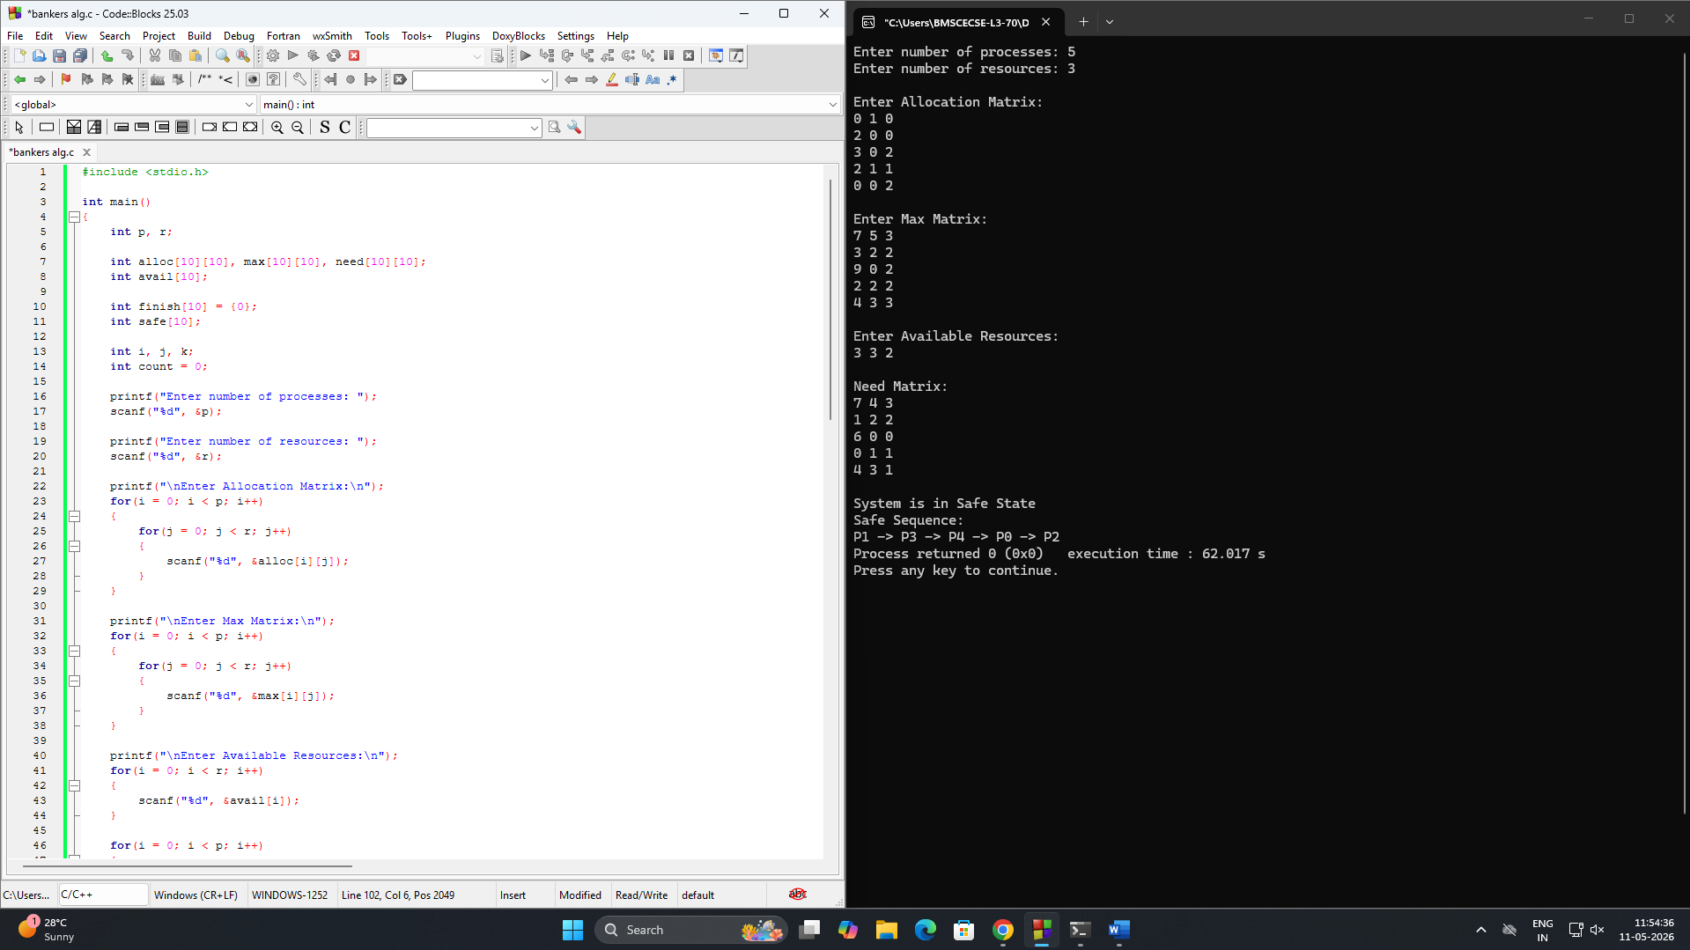

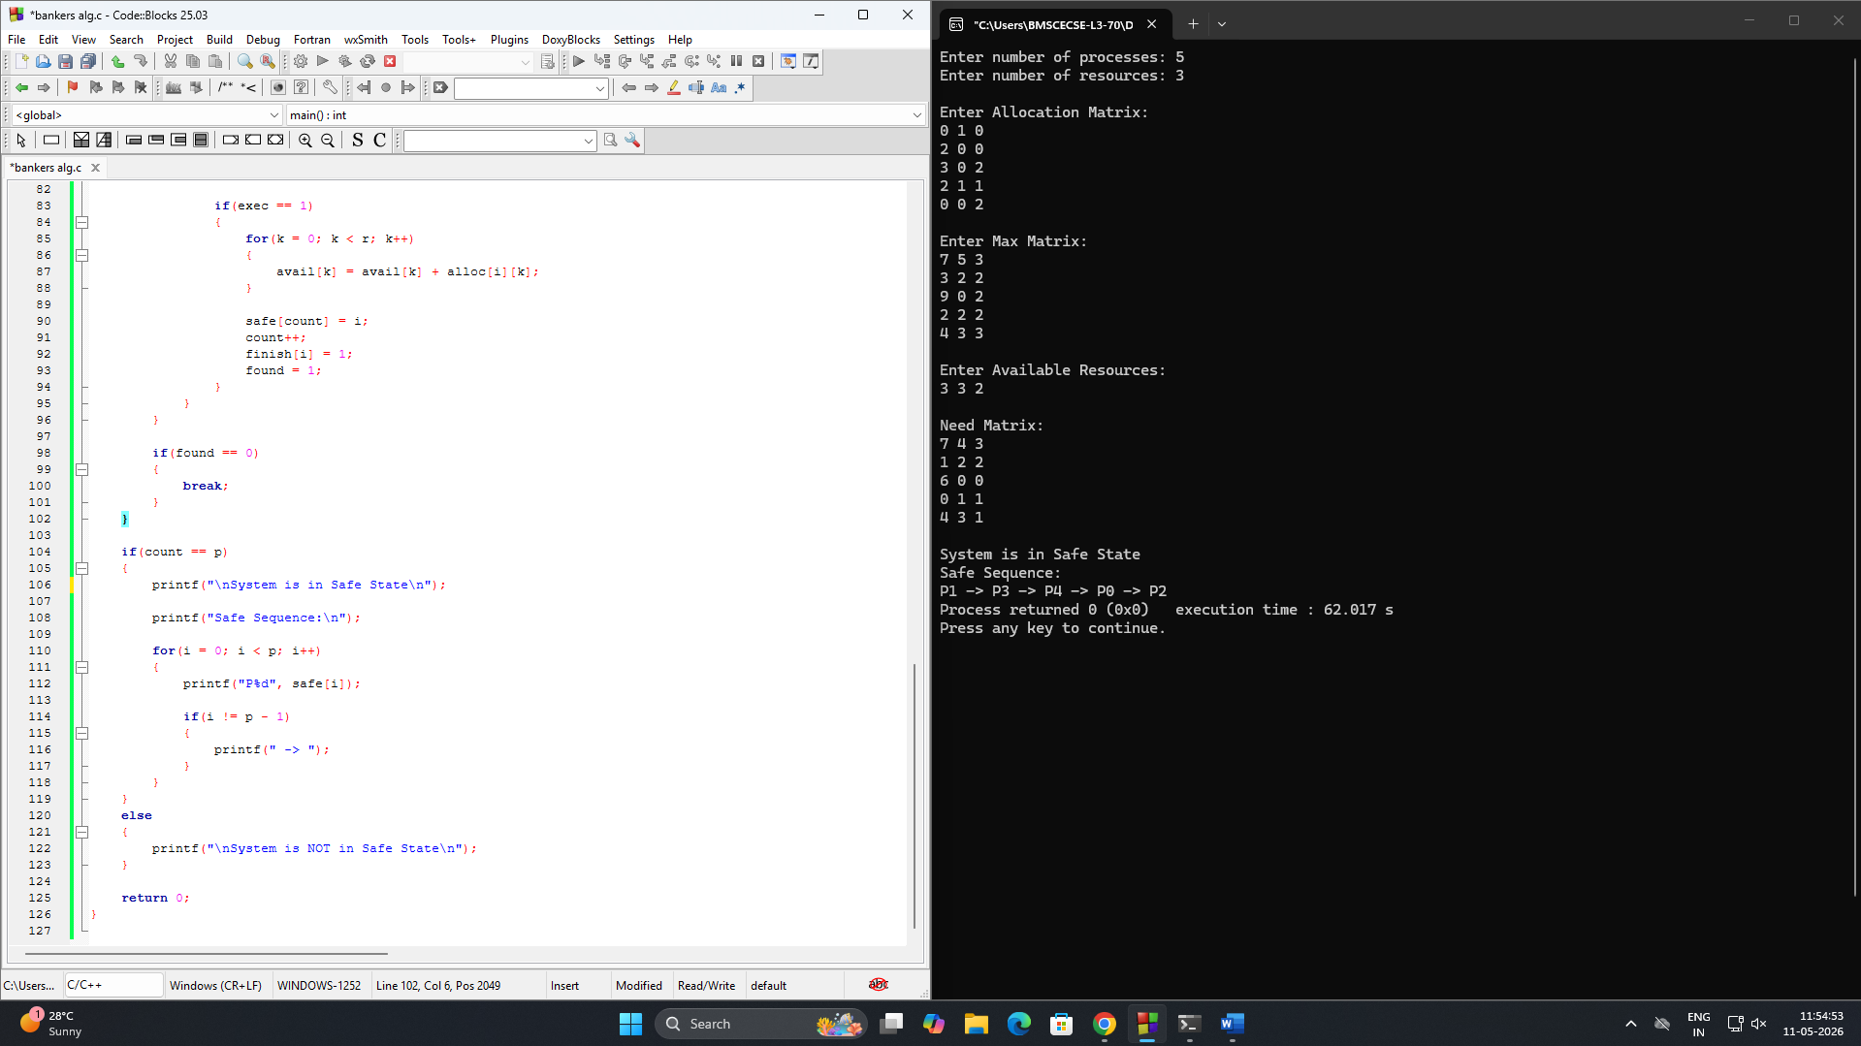

b)
#include <stdio.h>

int main()
{
int p, r;

int alloc[10][10], req[10][10];
int avail[10];

int finish[10];
int deadlock = 0;

int i, j, k;

printf("Enter number of processes: ");
scanf("%d", &p);

printf("Enter number of resources: ");
scanf("%d", &r);

printf("\nEnter Allocation Matrix:\n");
for(i = 0; i < p; i++)
{
for(j = 0; j < r; j++)
{
scanf("%d", &alloc[i][j]);
}
}

printf("\nEnter Request Matrix:\n");
for(i = 0; i < p; i++)
{
for(j = 0; j < r; j++)
{
scanf("%d", &req[i][j]);
}
}

printf("\nEnter Available Resources:\n");
for(i = 0; i < r; i++)
{
scanf("%d", &avail[i]);
}

for(i = 0; i < p; i++)
{
int sum = 0;

for(j = 0; j < r; j++)
{
sum = sum + alloc[i][j];
}

if(sum == 0)
{
finish[i] = 1;
}
else
{
finish[i] = 0;
}
}

while(1)
{
int found = 0;

for(i = 0; i < p; i++)
{
if(finish[i] == 0)
{
int exec = 1;

for(j = 0; j < r; j++)
{
if(req[i][j] > avail[j])
{
exec = 0;
break;
}
}

if(exec == 1)
{
for(k = 0; k < r; k++)
{
avail[k] = avail[k] + alloc[i][k];
}

finish[i] = 1;
found = 1;
}
}
}

if(found == 0)
{
break;
}
}

for(i = 0; i < p; i++)
{
if(finish[i] == 0)
{
deadlock = 1;
break;
}
}

if(deadlock == 1)
{
printf("\nSystem is in Deadlock State\n");

printf("Deadlocked Processes:\n");

for(i = 0; i < p; i++)
{
if(finish[i] == 0)
{
printf("P%d ", i);
}
}
}
else
{
printf("\nNo Deadlock Detected\n");
}

return 0;
}

Output:

